**DRIVING SCORE:**

* Could be also called PRUDENCE SCORE, or SAFE DRIVING SCORE.
* It is a global score of the prudence where prudence is “the opposite of risk” (RISK is LACK OF PRUDENCE).
* This score is calculated not to be too strict: you can have alerts, if they are not too numerous, you still can have a good score.
* This was made not to discourage drivers.

**ANTICIPATION**

* Anticipation is the ability not to go to red alert and not to come close to red alert (even if alert is not triggered)

**SELF CO NFIDENCE**

* Driver takes more risk and because it is the more frequent value, he thinks that he can cope with this higher risk.
* It may be true: if anticipation is very high  
  It may be wrong: if anticipation is very low, then driver is OVERCONFIDENT.
* So self-confidence is not “good or bad in itself”, it depends on the other estimators, including the last one (DRIVING SKILLS See below).
* Anticipation, self-confidence, and driving skills can be used together to decide how to improve (for a fleet driver):
* good anticipation, good driving skills, high self-confidence: ***good experienced and efficient driver***
* average anticipation, low driving skills, low self-confidence: ***driver does his best to be prudent but lacks of experience. More practice will help.***
* high self-confidence, low anticipation, low or average driving skills: **driver thinks he is a pilot, but he is a bad driver. He should drive slower and be retrained from the start with prudence rules**.

**DRIVING SKILLS**

* Driving skills is the ability to reproduce the same risk in the same situations. It is the opposition of dispersion of risk.
* Beginners have a very flat and dispersed risk distribution.
* Experienced drivers have a more reproducible risk.
* Pilots have a completely reproducible risk.
* Safe or unsafe is not the question: it is ***“***
* ***is it reproducible?”***
* An unsafe driver with a high driving skill does it on purpose. This driver doesn’t want to drive safe.

**RISK PROFILE**

* Our Software is a knowledge-based engine which at current state takes the dynamics of the vehicle (acceleration and speed) and an Electronic Horizon (HE) as Inputs
* The EH is obtained from map matching algorithms, and it corresponds to the most probable driving path in front of the vehicle.
* A dimensionless quantity 𝑟∈{0; 1} is the output.
* It gives an estimation of the risk at real time: if 𝑟 = 0, the risk does not exist, if 𝑟 = 1, the risk is high and a “near miss” accident is detected.
* This solution is also able to obtain a “risk profile” as a function of the distance along the most probable driving path in front of the vehicle.
* It is thus possible to fully anticipate the risk in the future considering the current behavior of the vehicle.

***Results and Discussion of validation tests***

Safety measurements have only been made by analyzing data collected from accelerometers so far, by assuming that a “severe breaking” (important acceleration variation) reflects a lack of anticipation, and thus, an unsafe behavior.

The variation of acceleration is also assimilated to the Eco driving attitude (Fuel consumption is related to acceleration variations). Hence in the severe breaking assumption, the safety is directly correlated to the Ecological driving attitude.

We have imagined four different scenarios to highlight the most common driving behaviors:

* The “Good” driver
* The “Quiet – dangerous” driver
* The “Bad” driver
* The “Expert Sportive” driver

***Driver profiles for those four scenarios are the following:***

* + The “Good” driver does not accelerate much and has a good anticipation when approaching a Dangerous Point of Interest (DPOI).
  + The “Quiet – Dangerous” driver does not accelerate much but does not stop at all when approaching a DPOI.
  + The “Bad” driver accelerates very often and strongly and does not slow when approaching a DPOI.
  + The “Expert Sportive” driver accelerates very often and strongly but slows down when approaching a DPOI.

*Each scenario has a duration of about 90s, following the same journey of 1,5 km. The Journey, driven by a professional driver, was mostly composed of traffic lights, pedestrian crossings and intersections, representing a typical journey in an urban environment.*

*To measure the impact of the individual driving attitude regarding the vehicular energy efficiency (“eco attitude”) when executing those scenarios, this module takes the acceleration and standard GPS frames as inputs. Then this software engine analyses acceleration signals following ten different rules and it outputs a dimensionless quantity varying from 0 to 100% which quantifies the eco driving style (“eco attitude”). The combination of the two modules allows obtaining point clouds in the Safety - Eco Space by collecting data at every second.*

*Point clouds in the Safety - Eco space (scale in percent) for those fours scenarios are given in Figure 2.*

*One can see that for the “Good” driver case (2.A), points are only confined in the green area, with safety values varying between 100% and 50%, and the Eco values are always around 70% and 75%, which corresponds to a good Eco attitude: the driver has a global safe and an eco-attitude at the same time.*

*In the “Quiet Dangerous” driver case (2.B), safety values vary between 100% and 0% and Eco values are around 70% and 75%.*

*In the “Bad” driver case (2.C), points spread all over Safety and Eco range, with a rather important number of points confined in the red area: the driver has a global unsafe and wasting attitude*

*Finally, in the Expert Sportive case (2.D), most of safety values are found between 100% and 50%, with a few of them below 50% though. Eco values otherwise vary between 70% and 0%.*

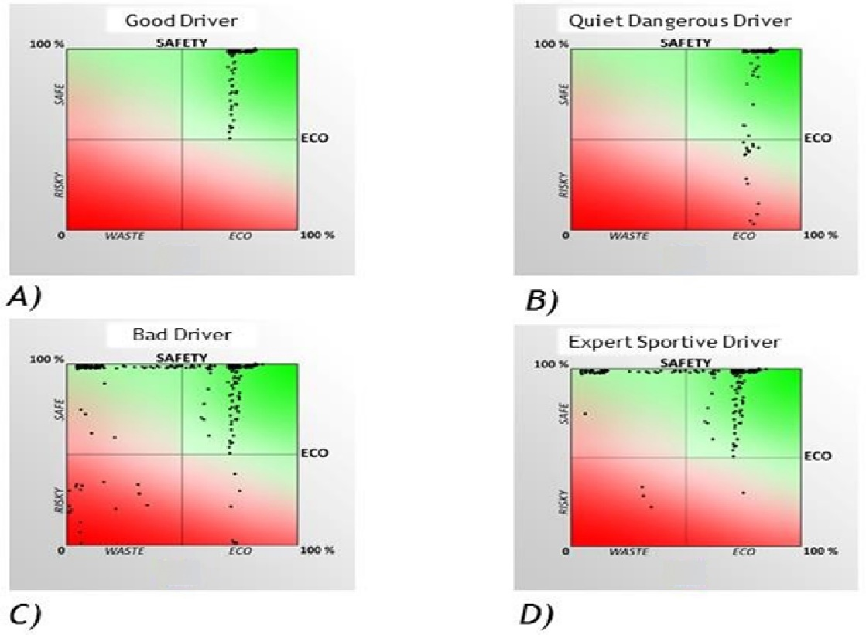

Figure 2

Let us discuss the “Quiet and dangerous” and the “Expert Sportive” driver cases.

*For the first case, the driver generates dangerous situations because he never slows down when approaching a DPOI, but has a good Eco driving attitude (the driver does not accelerate much, and keeps a relatively constant speed).*

*Hence, as an example, if the driver approaches a pedestrian crossing, he does not slow down to anticipate the presence of a pedestrian who would suddenly appear. So even though it has a good Eco driving signature, the driver is dangerous, which contradicts the idea that a good Eco driving attitude is necessarily safe.*

*Hence, there are in general no correlations between safe and ecological driving styles. This is visible from a formal point of view when observing the cloud point in the Safety - Eco space: one cannot fit the cloud point with a linear curve passing at the origin and having a slope “one half”.*

*The Expert Sportive driver case, in the opposite, does not generate dangerous situations most of the time, even if his Eco driving attitude is very bad (the driver accelerates and brakes very often and rather strongly).*

**Conclusion**

We show that our approach is more appropriate to estimate the real safety level than accelerometers and the so called “severe breaking” assumption.

In particular, by studying four different driver profiles, the “Good”, the “Bad”, the “Quiet Dangerous” and the “Expert Sportive”, we show that safe and ecological driving styles (measurement of acceleration variation) are not correlated.

Hence, the “severe breaking” assumption falls down. This is particularly visible for the case of the “Quiet Dangerous” driver. Indeed, the driver does not accelerate (Good Eco score), however he does not slow down when approaching a dangerous area (Bad Safety Score) but passes through it at constant speed.

Upon the “severe breaking” assumption, the diver would be given a good score, whilst he is clearly dangerous. This is a clear illustration of the fact that the “severe breaking” assumption is not appropriate to measure real safety level.

As a further extension of our solution, weather conditions and the grip of the road could be added to inputs. The risk estimation could be also improved by adding a camera in order to merge signals obtained from the road/obstacles detection in front of the vehicle.

Finally, in addition to an autonomous car, this solution can be used either for making data-based services richer or for a more relevant estimation of safety level and a better accident anticipation for any type of vehicles e.g. by the insurance sector.

* ***end of document -***